DEBT COLLECTION AGENT - CASE STUDY
Enterprise Multi-Agent Intelligence Platform for Autonomous Loan Collections
________________________________________________________________________________
1. PROBLEM STATEMENT (Data-Driven)
• Industry / Customer Context:
- A leading NBFC (Non-Banking Financial Company) running large-scale loan collections operations across India. The organization managed portfolio recovery across thousands of borrowers monthly, relying on a combination of internal collections teams, third-party agencies, and field agents operating across multiple geographies.
• Core Problem Identified:
- The loan collections workflow relied entirely on manual quality assurance and rule-based case assignment, both of which proved unsustainable as portfolio volumes grew. Quality managers could audit only 8-16 calls per agent per month across 60-75 agents per tier, leaving 95% of borrower conversations unmonitored. Case routing was static, new borrowers were assigned based on predefined rules that did not adapt as behavior emerged. Collections teams used multiple disconnected systems: CRM for case management, separate contact center platforms for outbound calls, manual spreadsheets for field agent routing, and ad-hoc dashboards for performance tracking.
• Supporting Data Points:
- QA coverage: Only 5% of calls audited (8-16 calls per agent per month); 95% of borrower interactions went unmonitored
- Case routing time: 2-3 days for manual case triage and allocation to agents
- Compliance breaches discovered weeks after occurrence through reactive audits
- Portfolio segmentation was static and rule-based, not adapting to emerging borrower behavior
- Field agents operated on inefficient, manually planned routes with no real-time deviation monitoring
- No unified system to coordinate multi-channel outreach (SMS, email, calls, field visits, legal notices)
- Generic SaaS tools could not distinguish fatal compliance breaches from minor errors
• Why It Mattered:
- Compliance risk: Fatal violations such as confidential information disclosure and abusive language were discovered only after borrowers escalated or regulators inquired, creating serious regulatory exposure
- Revenue impact: Misaligned case routing sent high-value recovery opportunities to underperforming agents, directly lowering recovery rates
- Operational inefficiency: Manual triage and disconnected systems created 2-3 day delays in case allocation, slowing the entire collections cycle
- Scalability ceiling: As portfolio volumes grew, the manual QA and routing model collapsed; there was no viable path to scale without proportional headcount increase
- Strategic risk: Generic SaaS platforms could not be adapted to the organization's proprietary risk criteria or integrated with internal borrower data, limiting intelligence quality
________________________________________________________________________________
2. IMPACT OF THE PROBLEM (Functional, Emotional & Social Pain)
• Operational Pain:
- Manual QA was subjective and inconsistent: two managers would score the same call differently, making quality benchmarking unreliable
- Only 5% call coverage meant fatal errors (confidential disclosure, abusive language) routinely went undetected until borrower escalation or regulatory inquiry
- Case allocation took 2-3 days and did not account for agent performance history, specialization, geographic proximity, or current workload
- Multi-channel outreach was uncoordinated: borrowers received repetitive, unrelated contact attempts from different teams with no shared context
- Field agents followed manually planned routes, resulting in wasted travel time and reduced daily visit capacity
- No mechanism to re-classify borrower risk in real time based on contact responses, meaning allocation decisions became stale quickly
• Emotional Impact:
- Leadership stress: Collections managers had no real-time visibility into agent compliance, borrower sentiment, or recovery progress; all insight arrived days or weeks later
- Quality manager burnout: Reviewing 8-16 calls per agent manually was time-consuming, repetitive, and still left 95% of interactions unreviewed
- Agent frustration: Collections agents received delayed, generic feedback that did not help them improve specific behaviors for the next call
- Compliance anxiety: Leadership operated under constant risk of regulatory inquiry due to unmonitored agent conduct across thousands of daily interactions
• Social / Organizational Consequences:
- Cross-team friction: Disconnected CRM, contact center, and field routing systems created data silos and inconsistent borrower records across teams
- Agency relationship friction: Third-party collection agencies received uneven case distributions unrelated to their performance history, creating disputes and misaligned incentives
- Borrower dissatisfaction: Uncoordinated outreach meant borrowers received multiple unrelated contact attempts from different channels, damaging repayment willingness
- Reputational and regulatory risk: Compliance violations discovered late exposed the organization to borrower complaints, regulator scrutiny, and potential penalties
• Cost of Inaction (quantified):
- Scaling the manual QA model to match portfolio growth would require proportionally more quality managers, adding significant headcount cost with no improvement in coverage or consistency
- Continued 95% blind spot on call quality guaranteed ongoing compliance exposure, with each undetected violation a potential regulatory fine or reputational incident
- Static case routing would continue misallocating high-value recovery opportunities, directly limiting portfolio recovery rates and revenue
- Competitor NBFCs adopting intelligent collections platforms would outperform on recovery rates and compliance, putting the organization at a structural disadvantage
________________________________________________________________________________
3. SOLUTION PROVIDED (Pain Relievers & Gain Creators)
• Solution Overview (1-2 lines):
- Debt Collection Agent is a composable, modular multi-agent intelligence platform deployed within the client's own cloud infrastructure (Azure/AWS), replacing manual QA, static case routing, and disconnected outreach systems with a unified, autonomous collections operating layer.
• Key Features Implemented:
- Feature 1: Classification Agent - Pain Relieved: Static, inaccurate portfolio segmentation
- Applies ML models trained on the client's historical data (pre and post-sanction attributes, payment history, demographics, financial profile) to assign each borrower one of five risk tiers: Very Likely to Default, Likely to Default, Neutral, Unlikely to Default, Very Unlikely to Default. Re-classifies borrowers dynamically in real time as contact responses and payment actions arrive.
- Impact: Portfolio segmentation that adapts as borrower behavior emerges, ensuring collections effort is always directed at highest-risk, highest-value opportunities first
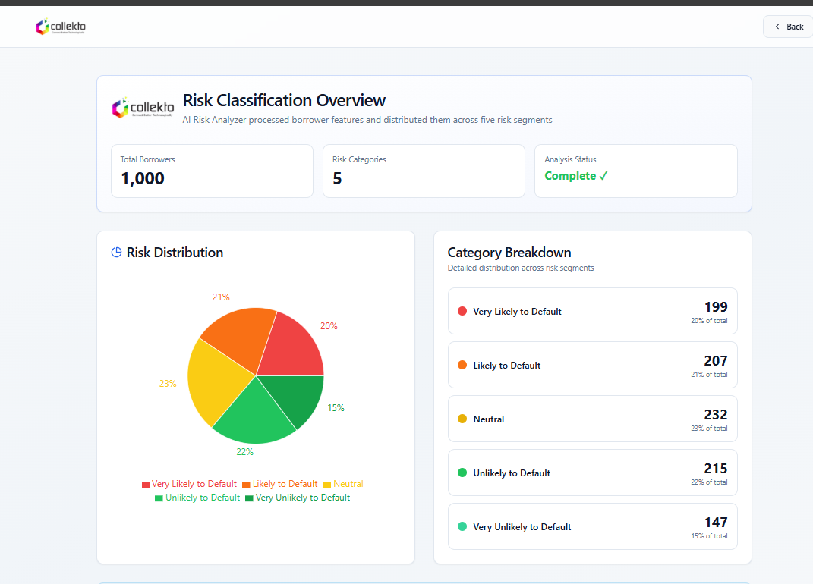
- Feature 2: Decision Making and Allocation Agent - Gain Created: Intelligent, performance-based case routing
- Routes cases through three sequential decisions: (1) Internal vs. external allocation based on risk tier and policy; (2) Specific third-party agency selection based on historical recovery rate for similar borrower profiles, agent specialization, geographic proximity, and current workload; (3) Optimal communication channel sequence (SMS, WhatsApp, email, telecall, field visit, legal notice) based on risk tier and prior contact outcomes.
- Impact: Case allocation time reduced from 2-3 days to minutes. High-value cases consistently routed to highest-performing agents. Channel sequencing optimized to maximize contact success rates.
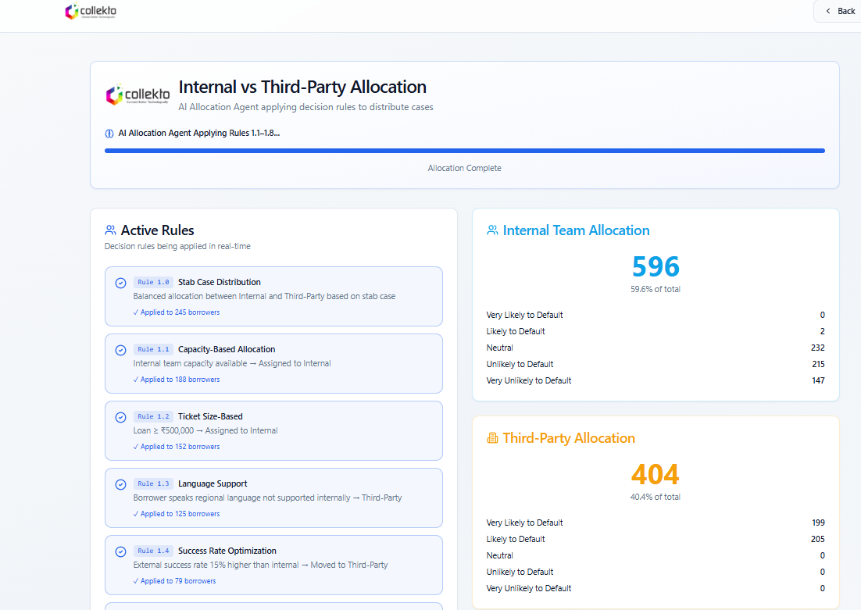
- Feature 3: Communication Agent - Gain Created: Coordinated, context-aware multi-channel outreach
- Orchestrates outreach across SMS, email, telecalls, field visits, and legal notices through a unified decision layer. Generates risk-tier-specific communication templates, tracks all touchpoints in a single log, monitors borrower responses (opened email, answered call, replied to SMS), and re-classifies borrower risk in real time based on response signals.
- Impact: Replaced scattered, repetitive contact attempts with coordinated outreach. Borrowers receive context-aware messages. Unified contact log eliminates cross-team data silos.
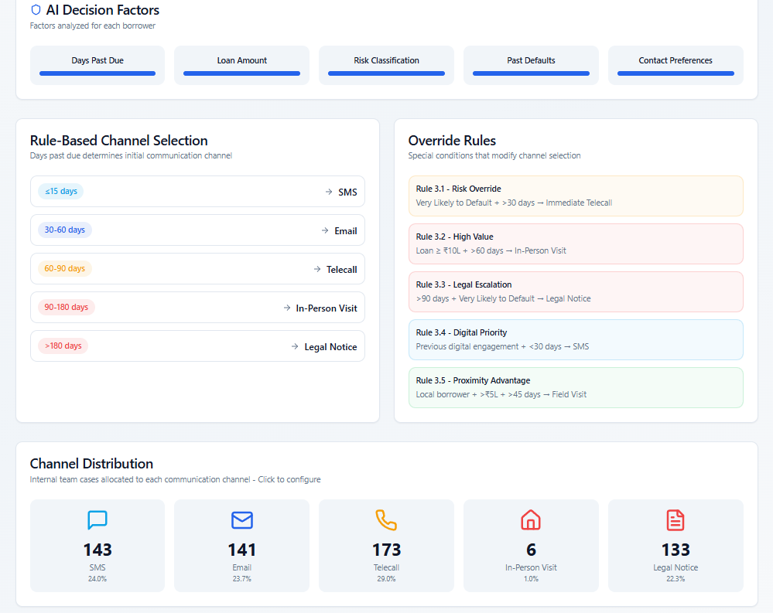
- Feature 4: QA (Quality Analysis) Agent - Pain Relieved: 95% unmonitored call blind spot and compliance exposure
- Analyzes 100% of inbound and outbound calls in real time using high-accuracy transcription (supporting Indian English, Hindi). Detects fatal compliance violations (confidential information disclosure, abusive language, procedure non-adherence) with immediate manager alerts. Scores non-fatal quality parameters (tone, greeting, probing for payment source, urgency creation, negotiation quality). Validates CRM disposition tags against actual call outcomes. Provides personalized next-call recommendations (timing, tone, talking points) and quartile-based agent rankings (Bottom/Mid/Top Quartile).
- Impact: QA coverage increased from 5% to 100%. Compliance breach detection shifted from reactive (weeks later) to real-time. Objective scoring replaced subjective manager evaluation. Agents receive specific, actionable feedback per call rather than generic periodic reviews.
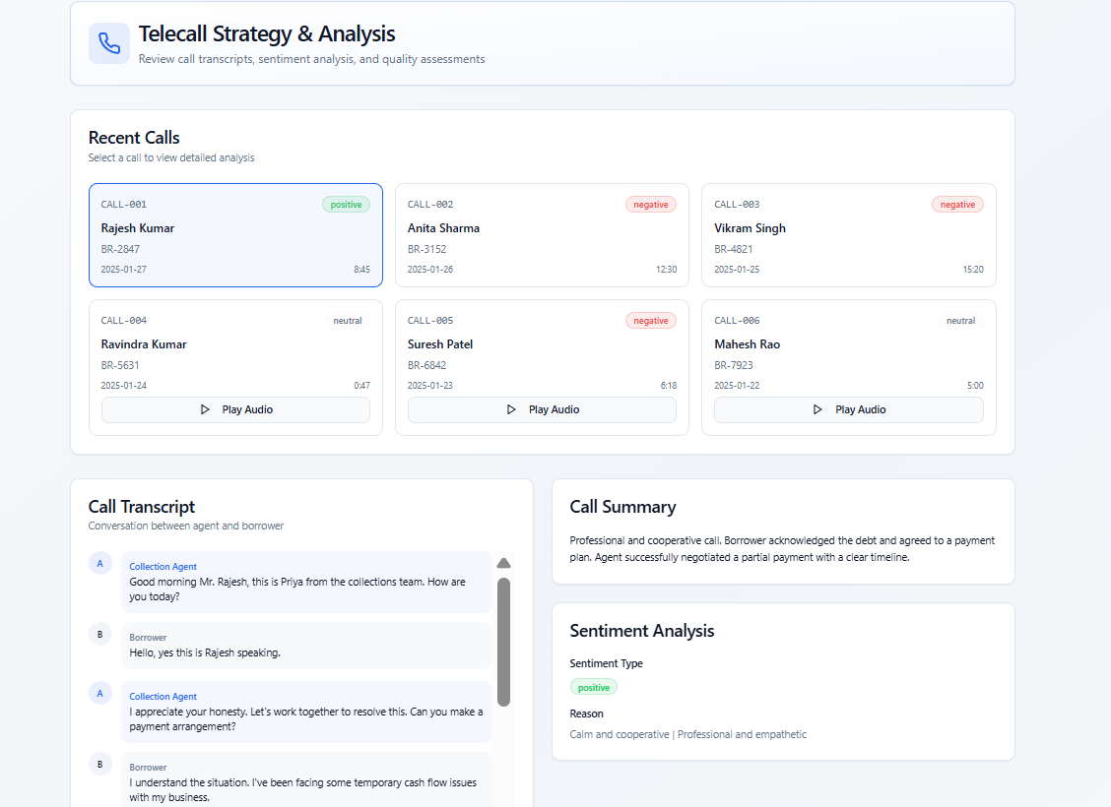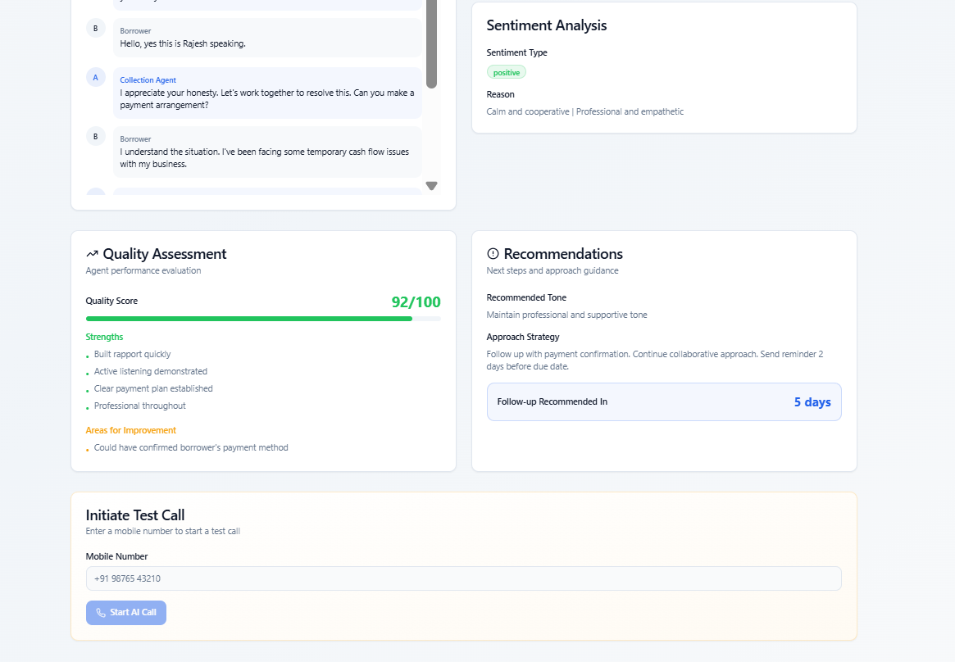
- Feature 5: Routing and Monitoring Agent - Efficiency Impact: Field agent productivity and fraud prevention
- Generates optimized visit sequences for field agents using route-planning algorithms. Provides real-time GPS tracking and detects spatial deviations (visiting unassigned addresses) and temporal deviations (visit duration anomalies). Alerts managers when deviations exceed configurable thresholds. Produces end-of-day productivity reports per agent.
- Impact: Reduced wasted travel time, increased daily visit capacity per agent, and enabled detection of suspicious field behavior (e.g., agents not visiting assigned borrower addresses).
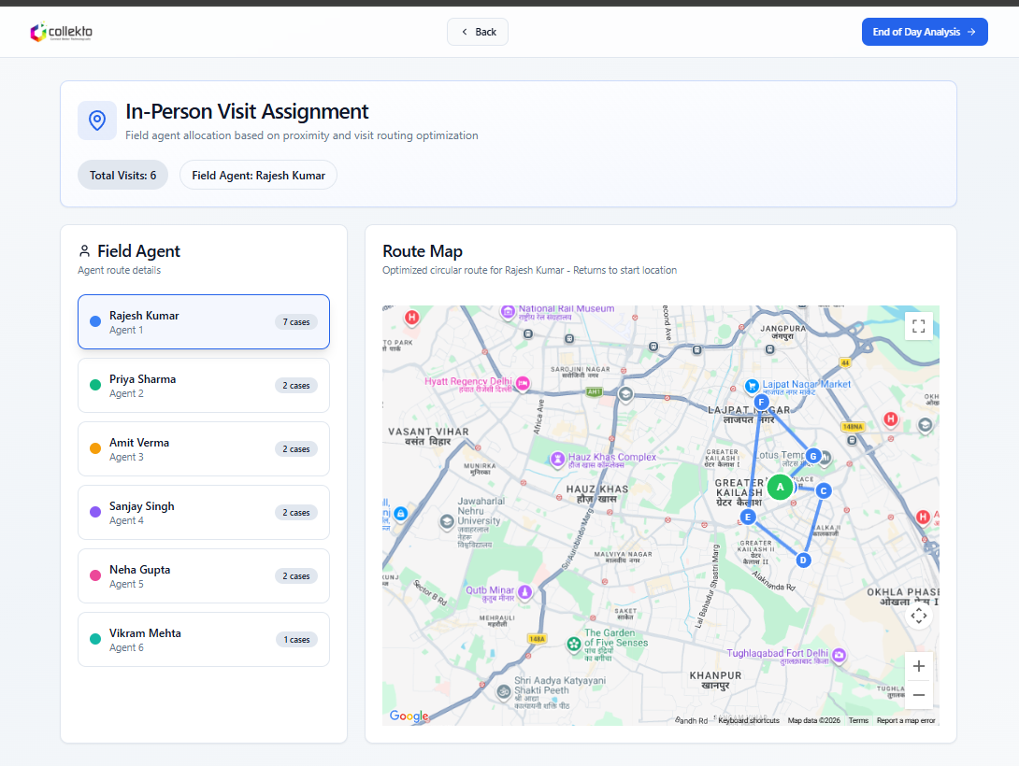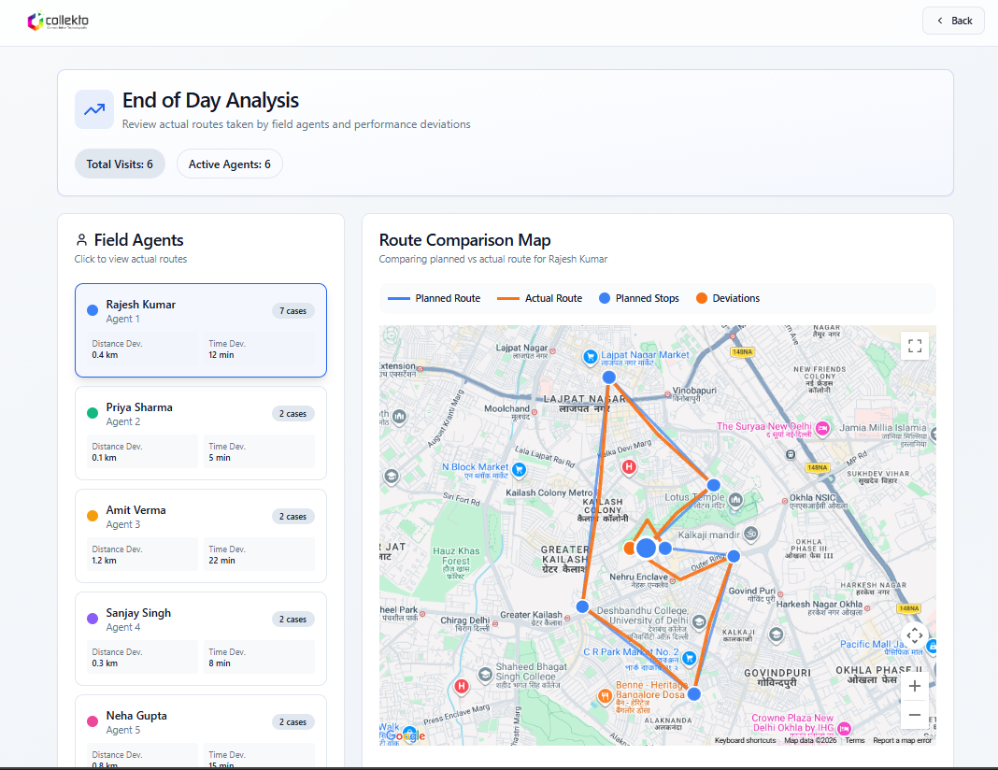
- Feature 6: Owned Intelligence Infrastructure - Governance Impact: Full data control and composability
- Deployed entirely within client's Azure/AWS environment. All call recordings, transcripts, and borrower data remain on client's servers. Clients choose which LLMs power each agent (OpenAI, Anthropic, open-source, or proprietary). Business rules, risk thresholds, communication templates, and escalation policies are fully configurable without code changes. Individual agents can be replaced or extended with proprietary models.
- Impact: No vendor lock-in. Client pays only for compute and inference consumed, no per-user SaaS seat fees. Full regulatory compliance on data residency. Platform reusable across credit underwriting, customer service, and compliance auditing with same agent framework.
• Implementation Approach:
- Timeline: Phase 1 (Weeks 1-3): Infrastructure deployment within client Azure/AWS, CRM integration, and borrower data pipeline setup. Phase 2 (Weeks 4-6): ML model training on client historical data for Classification Agent, QA parameter configuration, and communication template setup. Phase 3 (Weeks 7-8): Agent orchestration testing, manager dashboard rollout, and field agent mobile app deployment. Phase 4 (Week 9-10): Phased live deployment starting with QA Agent and Classification Agent, then full six-agent activation.
- Integration complexity: Medium-High. Required CRM integration for case management and disposition validation. Telephony integration for call ingestion and real-time transcription. Third-party agency API connections for allocation and performance tracking. GPS and mobile app integration for field routing. Power BI dashboard setup for management reporting.
- Change management strategy: Manager training on QA dashboard and real-time alert workflows. Agent onboarding for personalized feedback loop and quality scoring system. Third-party agency briefing on allocation logic and performance-based assignment. Phased rollout starting with QA and classification before enabling full autonomous allocation, building organizational trust in AI-driven decisions.
• Technical Capabilities & Architecture:
- Six-agent stateful orchestration: Classification, Decision Making, Allocation, Communication, QA, and Routing agents operating through a feedback-driven workflow with shared state and memory
- ML-based risk classification: Trained on client historical data; five-tier dynamic segmentation with real-time re-classification as borrower behavior arrives
- QA pipeline: High-accuracy STT (Indian English, Hindi, Hinglish, Telugu), NLP-based fatal parameter detection, sentiment analysis, disposition validation, weighted quality scoring
- Multi-channel orchestration: Unified outreach layer coordinating SMS, WhatsApp, email, telecalls, field visits, and legal notices through a single decision layer
- Route optimization: GPS-based field agent routing with real-time deviation monitoring and anomaly detection
- Infrastructure: Client-owned Azure/AWS deployment; swappable LLMs; no vendor data access; full audit logging and encryption controls
- Dashboards: Power BI-based manager dashboards for agent performance, team productivity, portfolio risk distribution, and outreach effectiveness
________________________________________________________________________________
4. OUTCOME (Quantified Results)
• Measurable Results:
Metric | Before | After | Improvement
Call QA coverage | 5% (8-16 calls/agent/month) | 100% of all calls | 20x coverage increase
QA objectivity | Subjective (varies by manager) | 90% match vs. human scoring | Consistent, unbiased scoring
Compliance breach detection | Reactive (weeks later) | Real-time alerts | Risk mitigated immediately
Case routing time | 2-3 days (manual) | Minutes (autonomous) | 100x faster allocation
Portfolio segmentation | Static, rule-based | Dynamic, real-time adaptation | Better targeting of high-risk cases
Field agent productivity | Inefficient manual routes | Optimized sequences + GPS tracking | Reduced travel time, more visits/day

- QA coverage improvement: From 5% to 100% of all calls analyzed in real time. This represents a 20x increase in compliance and quality visibility without additional QA headcount.
- Speed improvement: Case routing reduced from 2-3 days to minutes, enabling collections teams to begin outreach on new cases within the same business day as upload.
- Compliance breach containment: Violations that previously surfaced weeks after occurrence through reactive audits are now detected in real time, enabling manager intervention before borrower escalation or regulatory inquiry.
- Agent performance: Quartile-based scoring (Bottom/Mid/Top Quartile) identified underperforming agents for targeted training. Personalized per-call feedback accelerated skill development versus generic periodic reviews.
• Strategic Impact:
- Revenue and recovery improvement: Risk-based case routing consistently matched high-value recovery opportunities to highest-performing agents and optimal channels, improving portfolio recovery rates. Coordinated multi-channel outreach replaced scattered contact attempts, improving borrower response rates and repayment intent detection.
- Compliance and regulatory protection: Real-time QA coverage of 100% of calls eliminated the compliance blind spot that previously covered 95% of interactions. Fatal violation detection with immediate alerts enables proactive management response, significantly reducing regulatory exposure and the risk of borrower escalations.
- Scalability: The platform scales to any portfolio volume without proportional increase in QA headcount or operations staff. The same six-agent framework is reusable across credit underwriting, customer service routing, and compliance auditing, delivering compounding ROI across business functions.
- Owned intelligence: Full deployment within client infrastructure eliminates vendor dependency, ensures data residency compliance, and gives the client full control over risk models, business rules, and agent configurations as portfolio needs evolve.
• Human Impact:
- Reduced stress: Collections managers shifted from reactive crisis management to proactive optimization, with real-time dashboards replacing after-the-fact reporting and blind-spot firefighting
- Improved collaboration: Unified data layer across CRM, telephony, and field operations eliminated cross-team silos; all teams worked from the same borrower record and outreach history
- Agent development: Collections agents received specific, actionable per-call feedback tied to real conversation moments rather than generic periodic coaching, accelerating quality improvement
- Leadership confidence: Real-time compliance monitoring and predictable, rules-based routing gave leadership visibility and control over an operation that had previously been largely opaque
• Client Testimonial (Optional but Powerful):
"Before this platform, we were flying blind on 95% of our calls and spending days just allocating cases. Now we have full visibility, real-time compliance alerts, and our agents are actually improving because of the feedback. This has fundamentally changed how we run collections."
- Collections Head, Leading NBFC
________________________________________________________________________________
EXECUTIVE SUMMARY SNAPSHOT
Problem: Leading NBFC's collections operation monitored only 5% of calls, allocated cases manually over 2-3 days, and had no real-time visibility into compliance violations, borrower risk evolution, or field agent activity, creating systemic recovery inefficiency and growing regulatory exposure.
Solution: Deployed Debt Collection Agent, an owned six-agent intelligence platform (Classification, Decision Making, Allocation, Communication, QA, and Routing) operating within client's cloud infrastructure to autonomously segment borrowers, route cases, orchestrate multi-channel outreach, analyze 100% of calls, and optimize field operations.
Outcome: Achieved 20x QA coverage increase (5% to 100%), reduced case routing from days to minutes, shifted compliance breach detection from reactive to real-time, improved field agent productivity through optimized routing, and delivered a scalable owned intelligence platform requiring no proportional headcount growth as portfolio volumes increase.

